WEDE5020-POE-PART 1 improvements

[Company name] | [Company address]

ST10270409

Lonwabo Gumede

2023

**Table of content**

Contents

**Essay** 2

**Assets** 3

Screenshots of my website 10

Functionality 18

SEO 19

Forms 20

References 22

# **Essay**

**Amanzi(NGO)**

***Let’s be fresh!***

**Introduction**

We are a Non-Profit Organisation also known as NGO. We only operate in South Africa. Our purpose is to help the communities that are struggling. We provide services to communities that are suffering e.g., water. We are here to investigate the problem and come up with solutions.

**Causes of water problems in communities**

Recently, most communities in South Africa are having water issues. Most communities don’t have water due water pollution which includes poor sanitation. Climate change is another factor because the water evaporates differently, and the rainfall shifts in both hemispheres. Some people have money to fix water problems people in some communities instead they use it on something else which is very careless. Some citizens don’t have money to pay the government their taxes which leads to lack of infrastructure such as wastage. Lack of knowledge about water is another problem because people don’t know how to manage water which leads to them to wasting water.

**Impact of community having water problems**

Most people can’t wash dishes, use toilets, and wash hands. Some people don’t even have water tanks. Having no water can lead to dehydration and people can die from it. It is very hygienic which also leads to people smelling and having bad breath. Some communities can’t grow crops due to having no water and this is where malnutrition kicks and it increases the possibility of death and also diseases. Keeping a livestock requires water because people rely on keeping a livestock to find food and to earn an income which is difficult. Most hospitals and clinics find it difficult to help their patients safely due to lack of water.

**Solutions to water problems**

We will donate money to charities because charities help poor communities get access to water which improves sanitation, health, and agriculture. We will be investing in communities to allow themselves to have water. We will invest also in some communities’ education standards which will educate them the causes of water shortages, the effects, and the solutions and this can increase the awareness. We will build water tanks in poor communities so that people can gain access to water.

# **Assets**

These are the images I used for my website.

**Amanzi Logo**

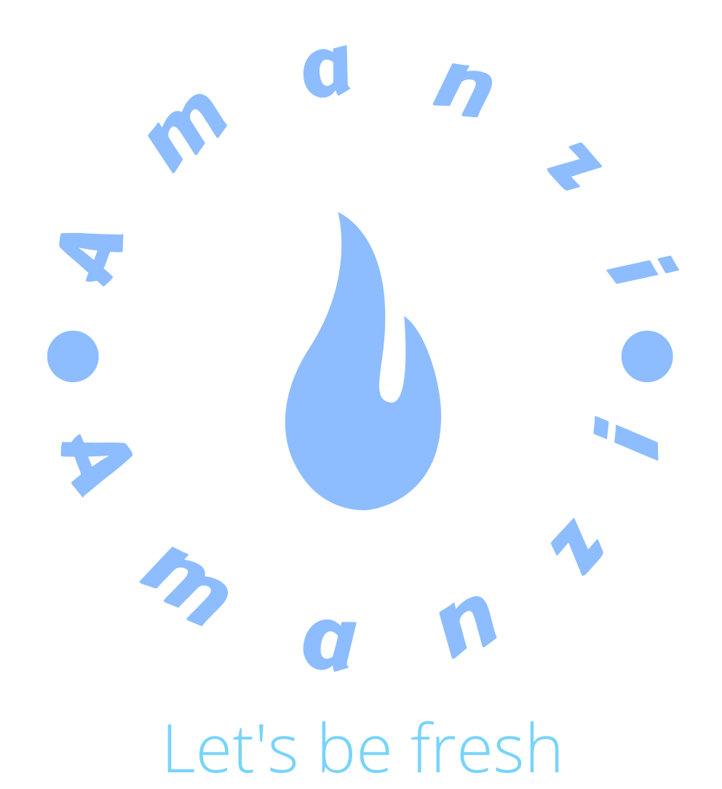

The logo represents hope. This is the logo, I used on my webpage. I used a website called LOGO.com to create this logo. <https://app.logo.com/editor/colors?editing_logo=logo_4a501ebd-0fa6-475f-8e20-cc9ce948621f>

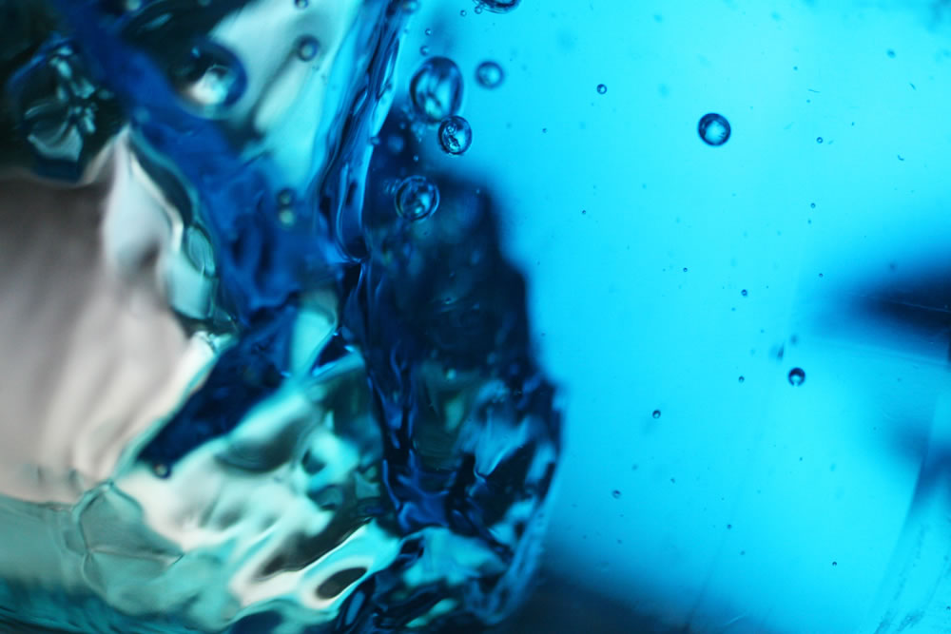

I took this image from the creative commons website.

<https://openverse.org/image/2f8088a3-696b-4b5b-9c6b-1d6fad96a3be?q=blue%20water>.

**2**"Blue Water" by fox_kiyo is licensed under CC BY-SA 2.0.

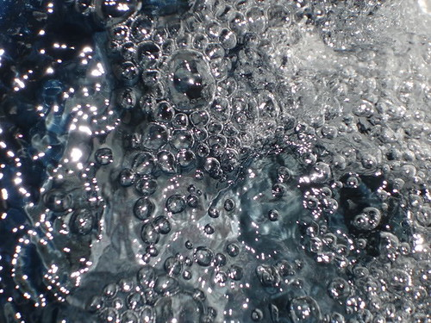

**3**"Water" by The-World-According-To-Pleiades is marked with CC0 1.0.

I took this image from the creative commons website. <https://openverse.org/image/e0e9b80f-52ac-4664-956e-3a597a8ce4ca?q=water>.



I took this old image from my phone.

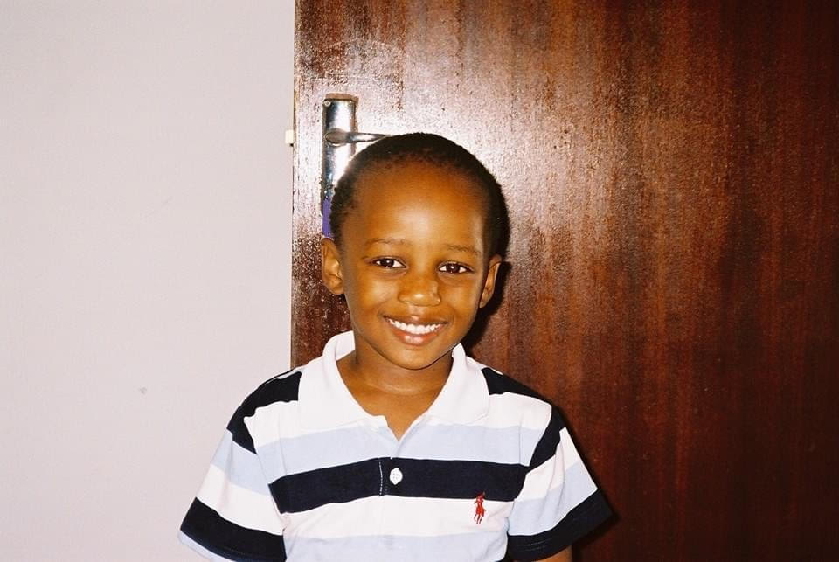

I took this old image from my phone.

I took this old image from my phone.

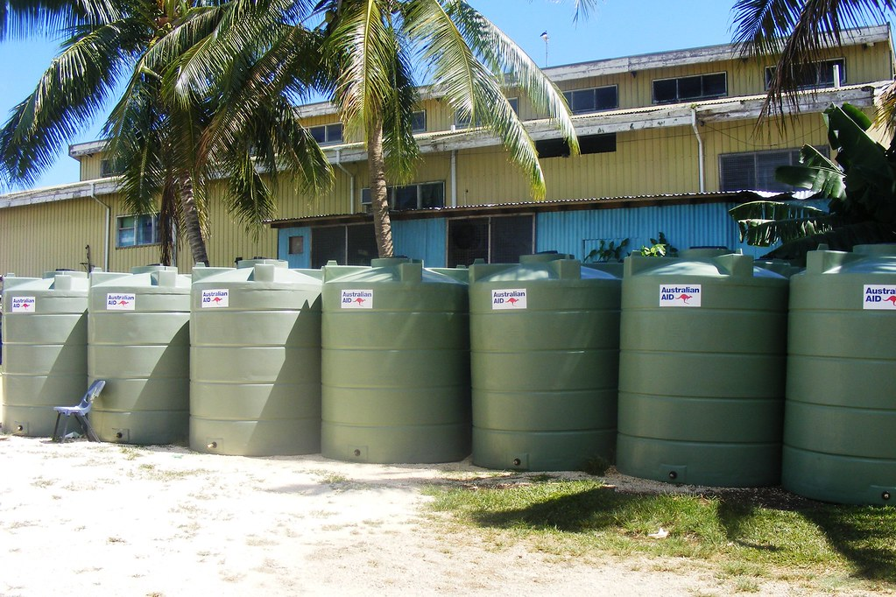

I took this image from the creative commons website. <https://openverse.org/image/e0e9b80f-52ac-4664-956e-3a597a8ce4ca?q=water> .

**4**"Palestinian water tanks destroyed by settlers in Hebron" by ISM Palestine is licensed under CC BY-SA 2.0.

Water tanks is what poor communities need because it helps them gain access to water.

# Screenshots of my website

This is my Home page

[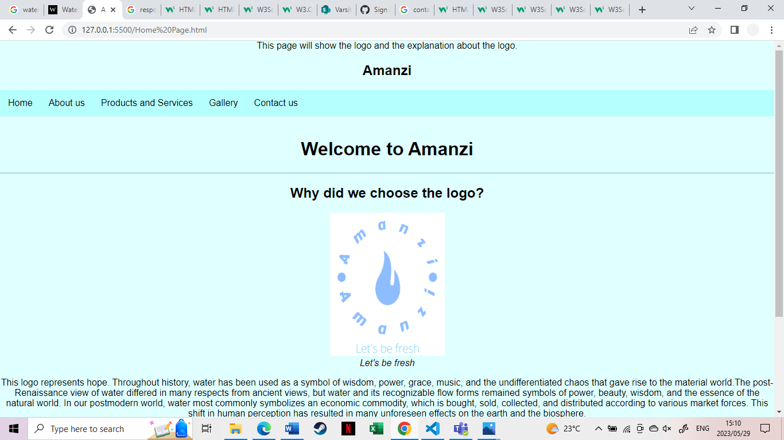](Home%20Page.html)

](Home%20Page.html)

This is my About us page.

[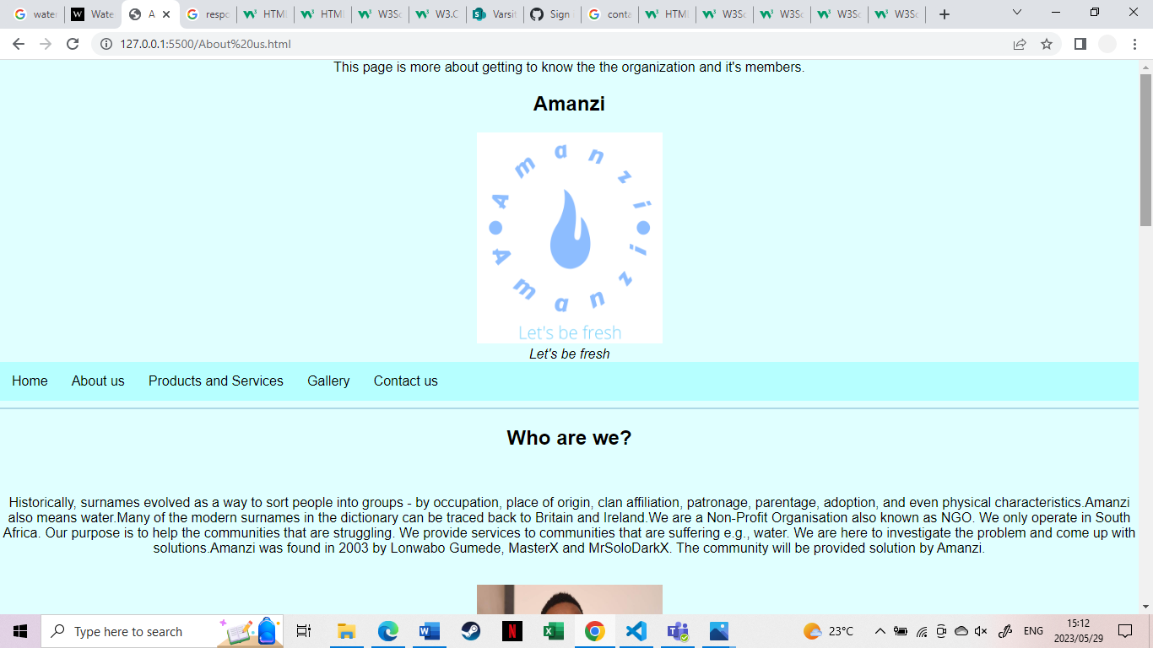](About%20us.html)

[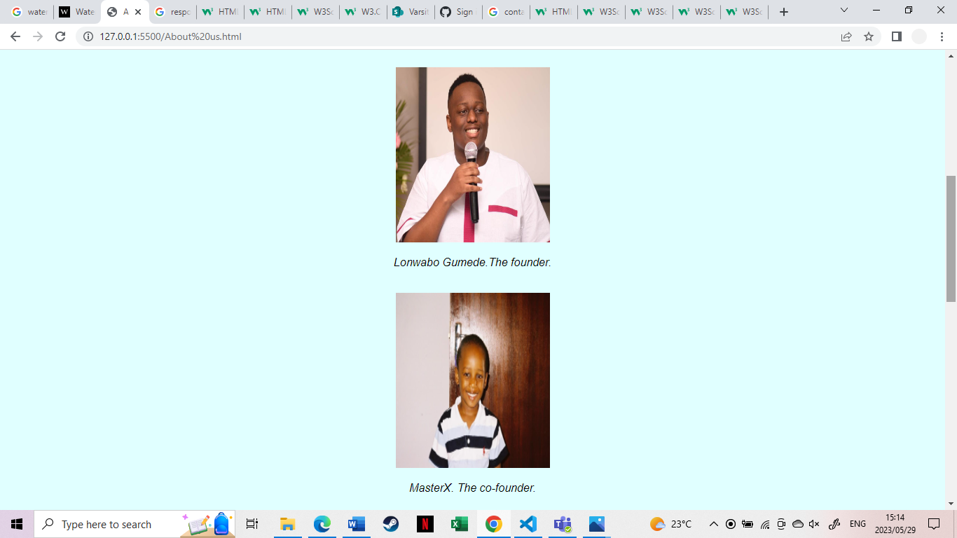](About%20us.html)

](About%20us.html)

](About%20us.html)

This is my Products and Services Page.

[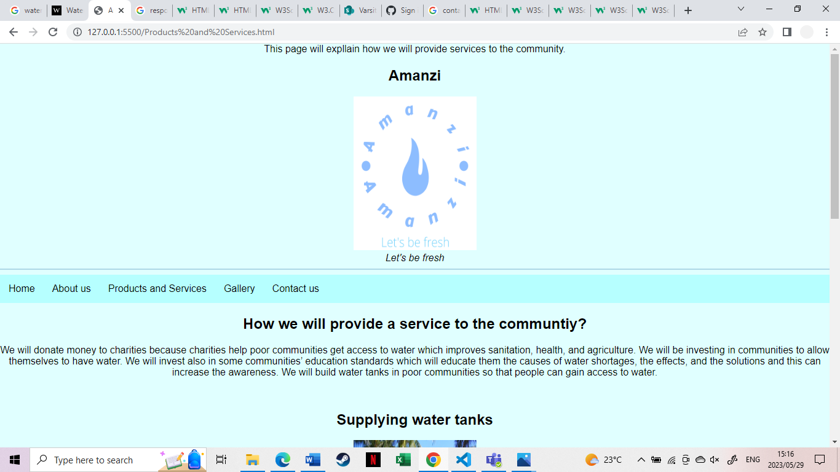](Products%20and%20Services.html)

](Products%20and%20Services.html)

](Products%20and%20Services.html)

This is my gallery page.

](Gallery.html)

](Gallery.html)

](Gallery.html)

This is my Contact us page.

](Contact%20us.html)

](Contact%20us.html)**Improvements to part 2**

# Functionality

Screenshot of the code.

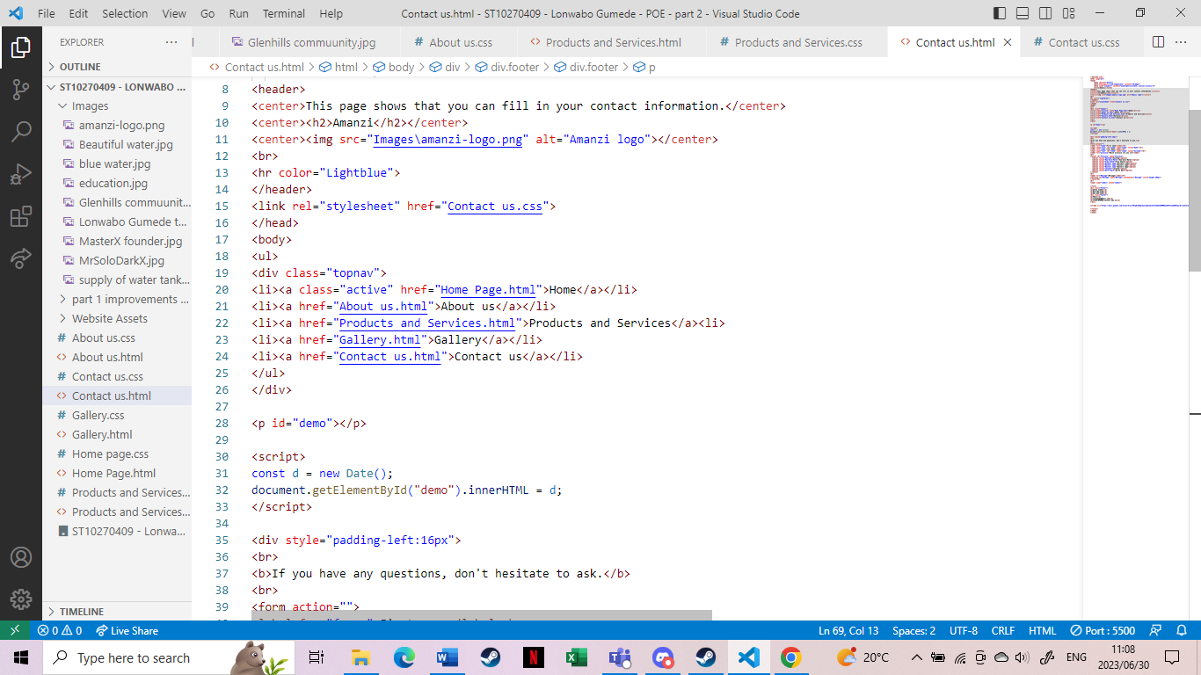

Screenshot of the code working.

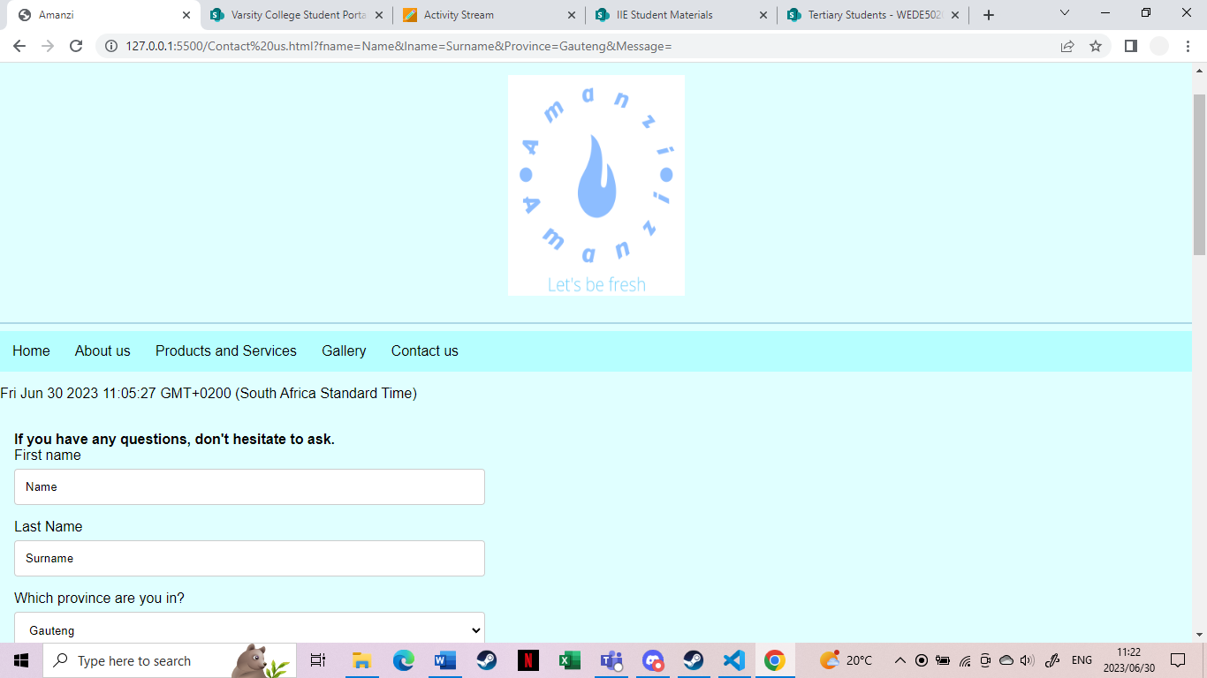

# SEO

I ensured that my website is responsive. The content is readable.There is no error with code. I ensured that all images have high quality. I used the appropriate font type and size for my content to ensure that it is readable. All of the files and images for the website are in the same location. I ensured that the links are not broken. That explains why it is easy to navigate through the website.

# Forms

This is the screenshot of google form working.

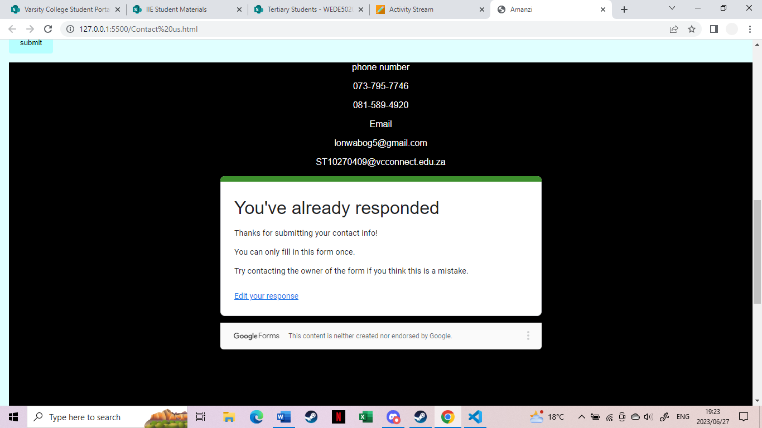

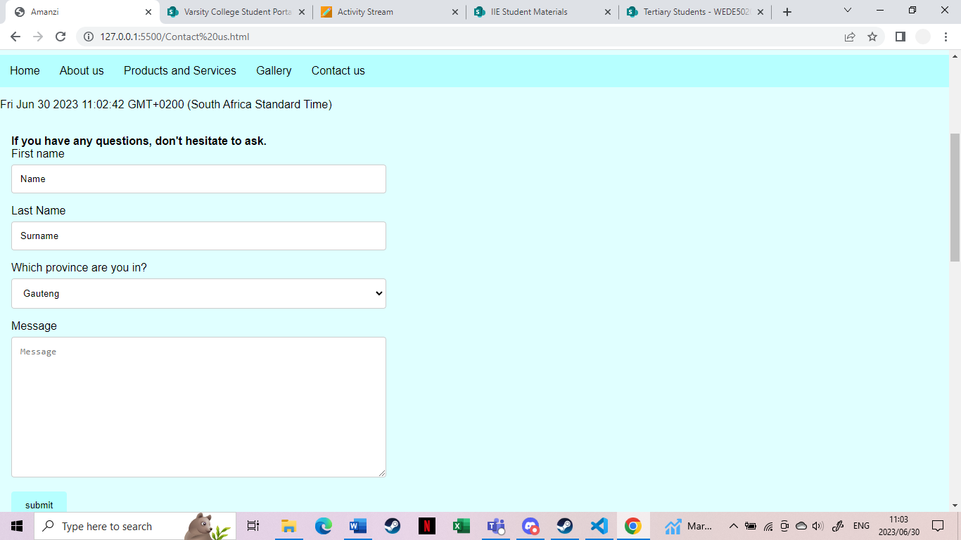

# References

Fox, 2007. *Flickr.* [Online]   
Available at: https://www.flickr.com/photos/84606435@N00/358207157  
[Accessed 3 April 2023].

Giunchedi, f., 2005. *flickr.* [Online]   
Available at: https://openverse.org/image/811bc9ff-6399-42ea-a348-8908a5afa69f?q=water%20logo  
[Accessed 03 April 2023].

Moon, S., 2006. *flickr.* [Online]   
Available at: https://openverse.org/image/e0e9b80f-52ac-4664-956e-3a597a8ce4ca?q=water  
[Accessed 03 April 2023].

Palestine, I., 2009. *Flickr.* [Online]   
Available at: https://www.flickr.com/photos/33983113@N02/3443049306  
[Accessed 03 April 2023].

Rinkesh, Unknown. *Conserve Energy Future.* [Online]   
Available at: https://www.conserve-energy-future.com/causes-effects-solutions-to-critical-problem-of-water-crisis.php  
[Accessed 3 April 2023 April 2023].